Deleted rows from "Restaurants" table with empty columns:

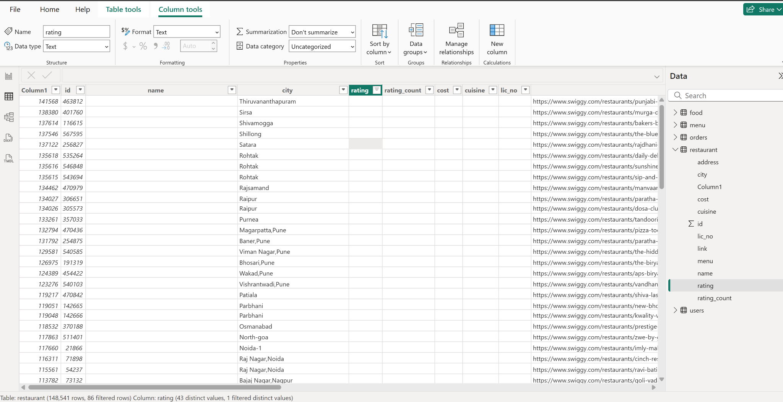

Rows deleted from “Order” table with currency as “USD”
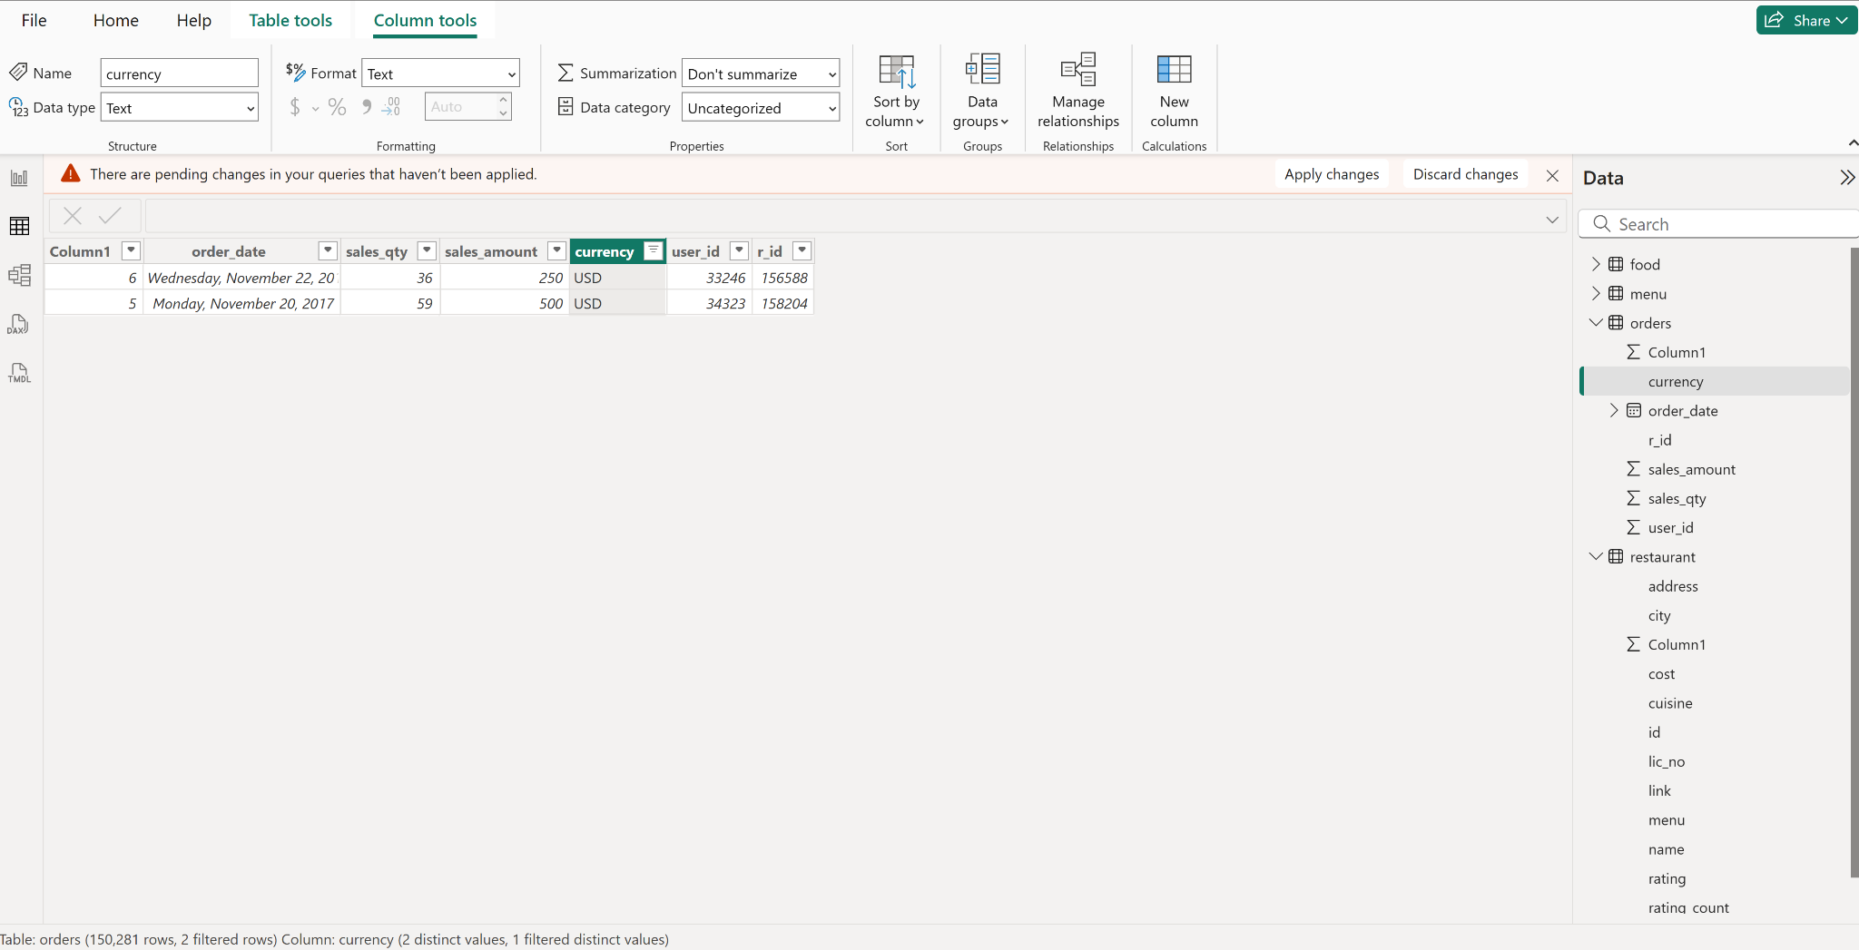

Rows deleted from “Order” table with sales_amount as “-1”
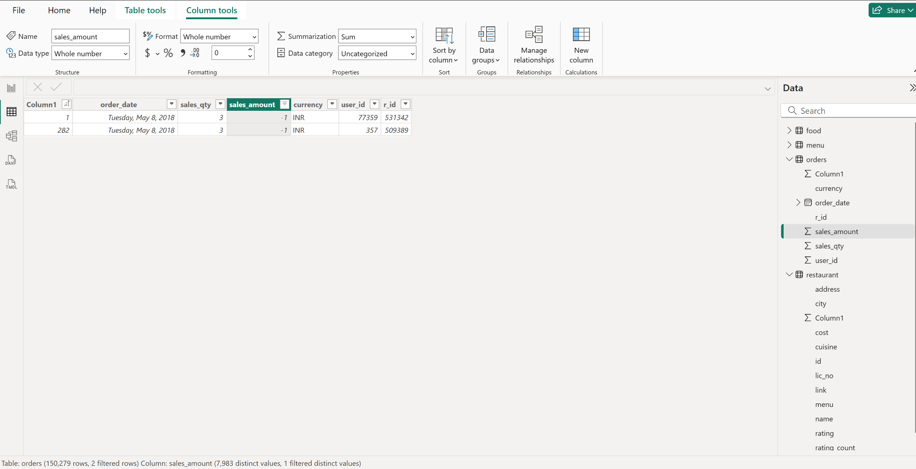

Added new column in “Restaurants” table:

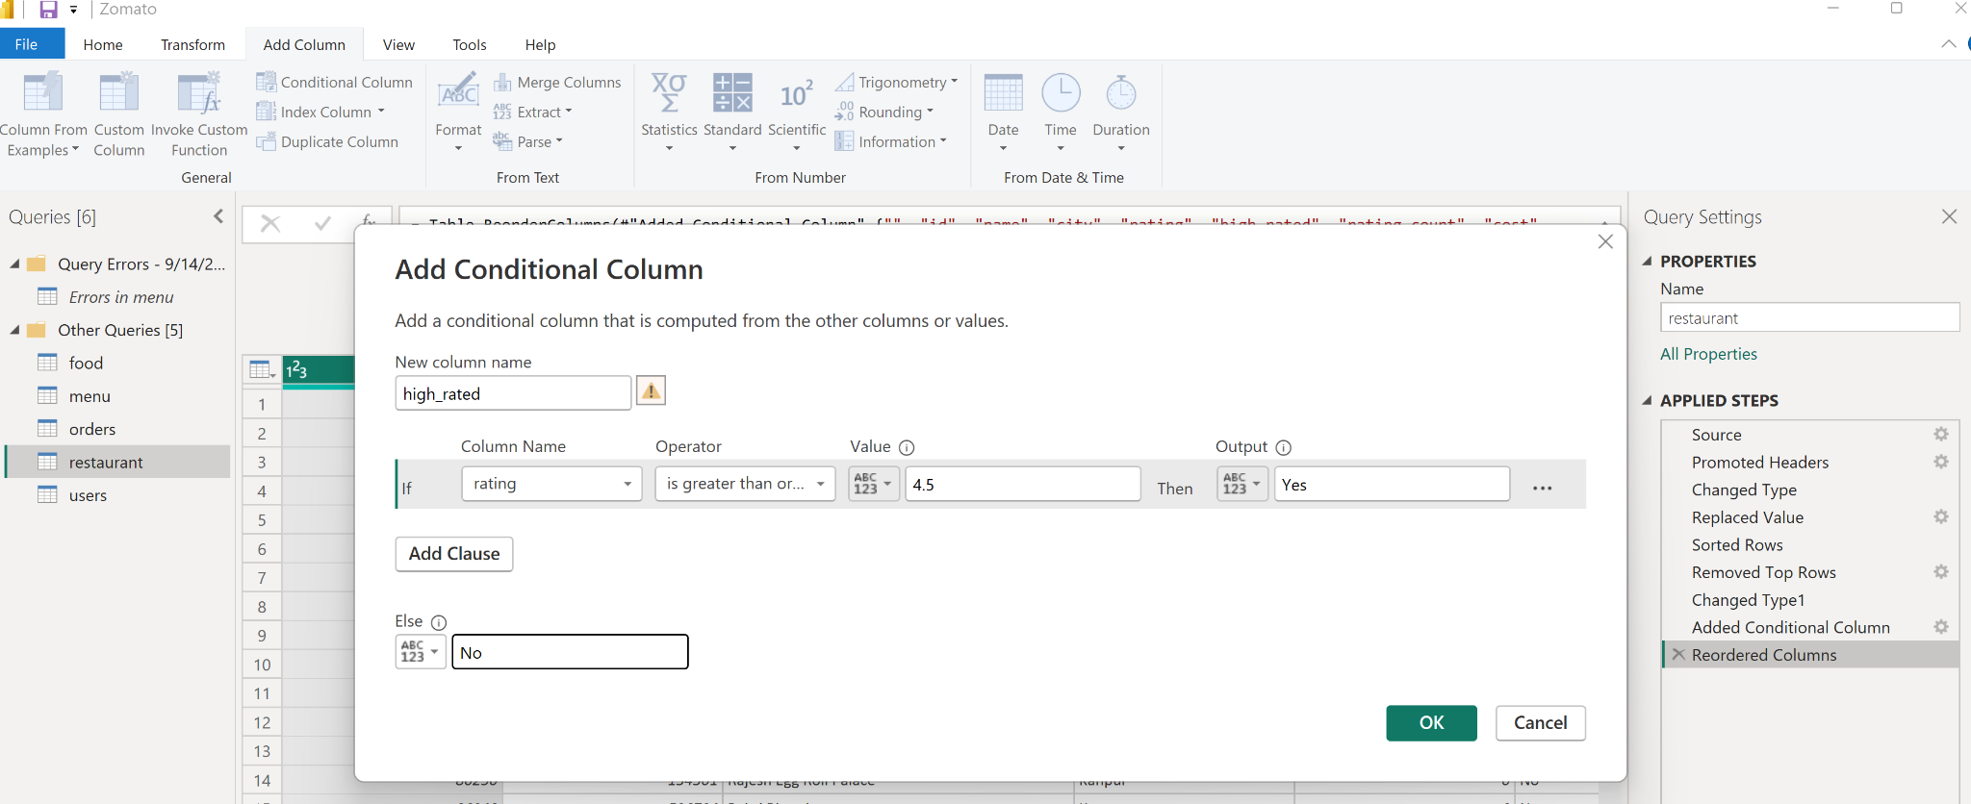

Deleted rows from “Restaurants” which does not have valid cuisines:

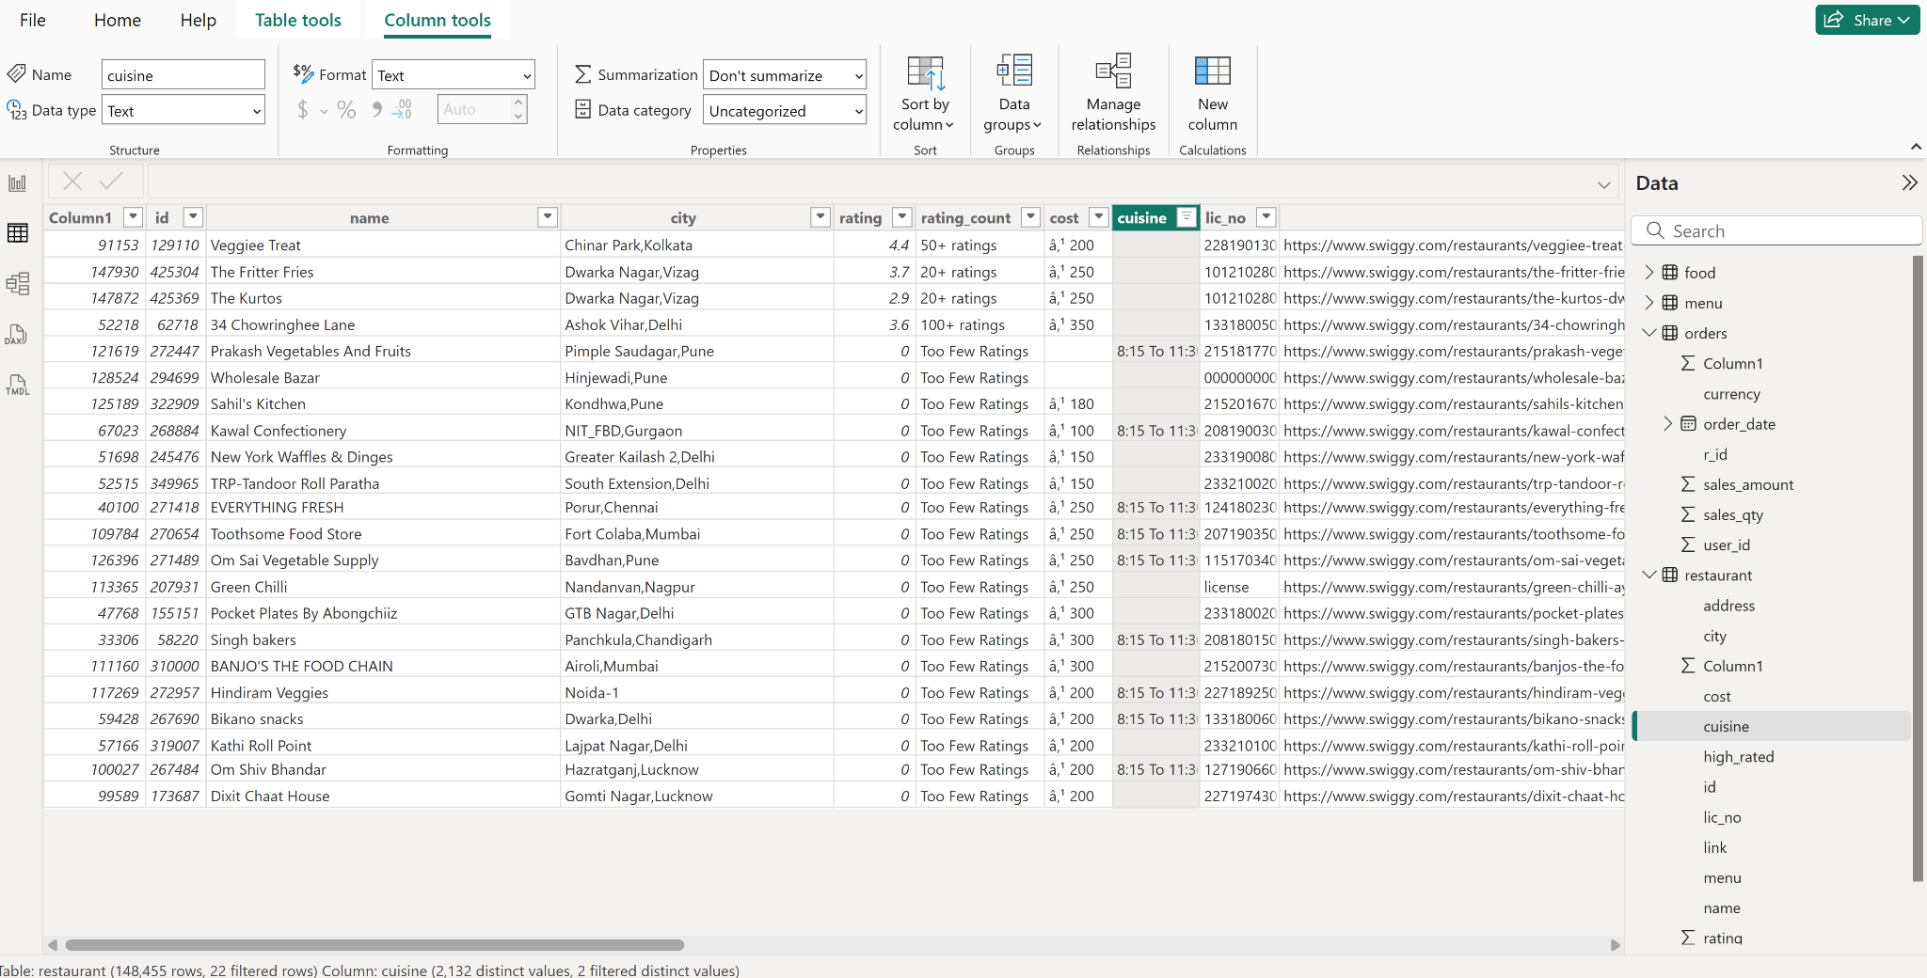

In Restaurant table, split cuisine column using “,” delimiter

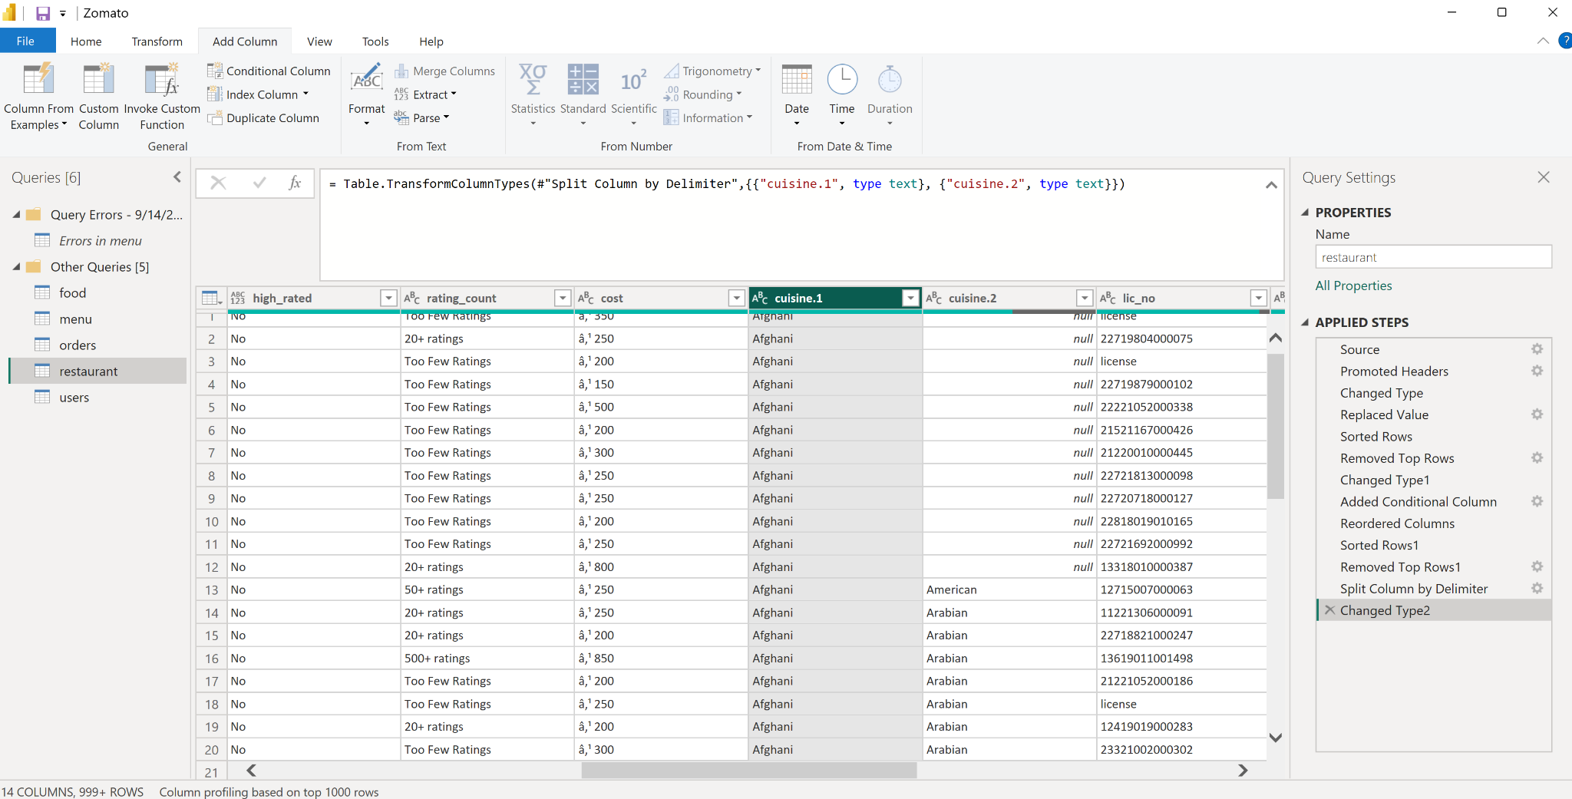

In Restaurant table split city column to remove area name from city:
